Project Design Phase
Proposed Solution Template

Date | 30 September 2026
Team ID | SWTID-2026-8886
Project Name | Implement Client Script and UI Policy for Incident
Maximum Marks | 2 Marks

Proposed Solution Template:
Project team shall fill the following information in the proposed solution template.
S.No. | Parameter | Description
1 | Problem statement | High-impact incidents may be incomplete or inconsistent at triage.
2 | Idea / solution | Use one UI Policy and three Client Scripts for clear form and list behavior.
3 | Novelty / uniqueness | Combines conditional field behavior, auto urgency, save validation, and list workflow in a small native-platform demo.
4 | Customer satisfaction | Clear requirements and immediate feedback reduce avoidable rework; validate with agents.
5 | Business model | Internal service quality improvement; no direct revenue model.
6 | Scalability | Reuse native Incident controls; add server-side rules if the policy must cover non-form paths.

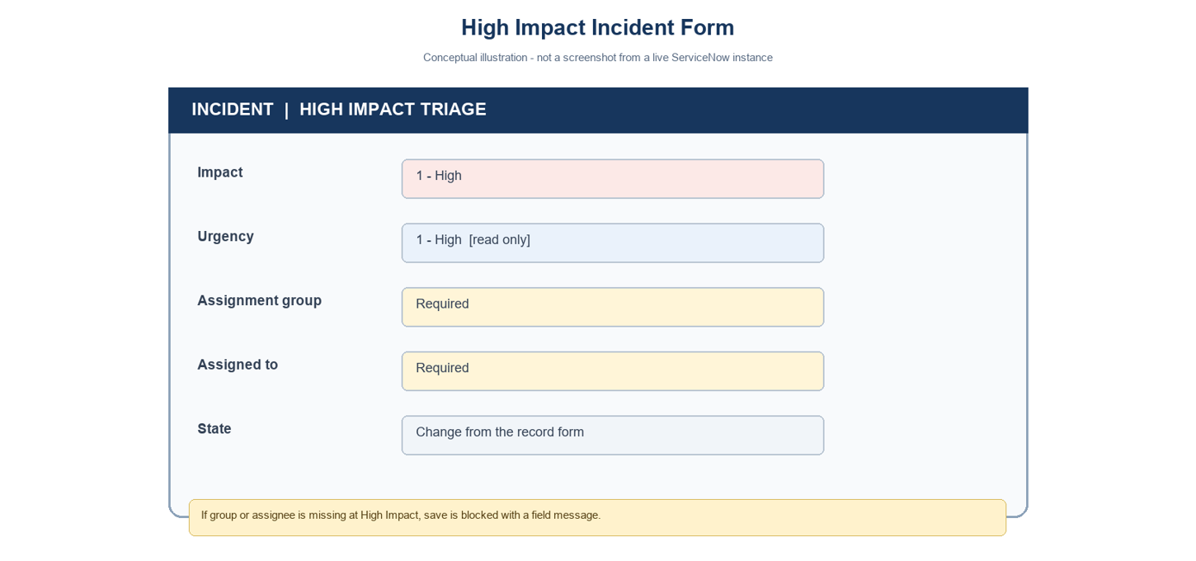
Proposed ServiceNow solution
Project note: values use the standard Incident choices where Impact 1 and Urgency 1 represent High. Confirm field names and values in the target instance.

